**ПРОГРАМА 77-Ї НАУКОВОЇ СТУДЕНТСЬКОЙ КОНФЕРЕНЦІЇЇ ОДЕСЬКОГО НАЦІОНАЛЬНОГО УНІВЕРСИТЕТУ ІМЕНІ І.І.МЕЧНИКОВА СЕКЦІЯ ФІЗИЧНИХ НАУК**

**(спільне засідання з Huaiyin Institute of Technology (КНР))**

Голова – д.ф.-м.н., проф. Адамян В.М.. Секретар – аспірант І.В.Теплякова

**Determination of ionization energy of molecules in the zero-range potentials approximation**

Stanislav Kuzmin,

Research Supervisor: professor Sc.D. V. Adamyan

Theoretical Physics and Astronomy Department,  
I. I. Mechnikov Odessa National University, Odessa, Ukraine

The aim of this work is to develop an effective method of description of the electronic structure of molecules and artificial polyatomic compounds based on the solvable model of zero-range potentials [1-4], .

There are few quantum-mechanical problems with exact solutions, even when it comes to the states of a single particle in an external field. However, if it is possible to model the influence of this field by the complex of the point perturbations like zero-range potentials, which in fact are simply boundary conditions of the form



imposed on the particle wave function at the points  where zero-range potentials are located [7], then the eigenvalue and eigenfunction problem for the corresponding Schrödinger equation reduces to a rather simple problem of linear algebra.

Application of this model allowed us to determine up till now the energy spectrum of one-electron excitations and the values of the ionization energies of some simple molecular compounds, using as initial data only the values of the ionization potentials of the constituent atoms and the geometry of the compound. At that it also appeared that obtaining explicit expressions for the one-electron eigenfunctions, and hence for the density of delocalized electrons in the molecules is a problem of low computational complexity. Moreover, the results of checking calculations for molecules of methane and ammonium turned out to be very close to the experimental data. Particularly, the calculated ionization potentials using atomic data from [8,9] for methane and ammonium without account of their ions motion are 13.31 eV and 10.27 eV, while the corresponding experimental values are 13.6 eV and 10.82 eV, respectively.

Such simplicity and precision of the method lead to important perspectives. In some cases, the zero-range potentials model may be no less effective for describing the electronic structure of molecules than the method of density functional or ab initio method. It is possible, that the further developing of working rules for incorporation of individual characteristics of composite systems in the zero-range potentials model will result in getting a simple tool for describing the electronic properties of not only simple molecules but also quantum dots and low-dimensional conductors.

**References**

1. Bethe, H., Peierls, R.: Quantum theory of the diplon. Proc. Roy. Soc. (London) 148A (1935), 146-156.

2. Wigner, E.: On the mass defect of helium. Phys. Rev. 43 (1933), 252-257.

3. Thomas, L. H.: The interaction between a neutron and a proton and the structure of H3. Phys. Rev. 47 (1935), 903-909.

4. Fermi, E.: SuI moto dei neutroni nelle sostanze idrogenate (In Italian). Ricerca Scientifica 7 (1936), 13-52. English translation in E. Fermi Collected Papers, Vol. I, Italy, 1921-1938. University of Chicago Press, Chicago-London, 1962, pp. 980-1016.

5. Yu. N. Demkov and V.N. Ostrovsky, Zero-range Potentials and their Applications in Atomic Physics, Plenum, New York, 1988

6. S. Albeverio, F. Gesztesy, R. Høegh-Krohn, and H. Holden, Solvable models in quantum mechanics. Texts and Monographs in Physics. 2nd edition, AMS-Chelsea Series, Amer. Math. Soc., 2005

7.F.A. Berezin and L.D. Faddeev, Remarks on the Schrödinger equation with singular potential, Doklady Akad. Nauk SSSR, 137, (1961), 1011 – 1014

8. Computational Chemistry Comparison and Benchmark DataBase, Standard Reference Database, Release 21 (August 2020) National Institute of Standards and Technology, CCCBDB introduction navigation (nist.gov)

9. Mathematica’s Element Data function from Wolfram Research, Inc., https://periodictable.com/Elements/001

**Models of active galaxy nuclei and results of monitoring and VLBI observations in the radio band**

Daniil Zabora

Research Supervisor: docent, Ph.D. V.Marsakova

Theoretical Physics and Astronomy Department,  
I. I. Mechnikov Odessa National University, Odessa, Ukraine

Work was carried out to study the variability of the radio flux of the active galactic nucleus (3C 120, 3C 273, 3C 345, 3C 454.3, 3C 446, BL Lac, CTA 102, OJ 287 OT 081) and their jets using vary large base radio interferometry data, as well as, their possible application in the further construction of more detailed physical models of specific active galactic nuclei.

Based on Fourier analysis, quasi-harmonic periods of variability in the radio flux of active nuclei and jets were obtained, and conclusions were drawn as to how they are related.

Based on the comparison of the identified periods of variability of jet and active nuclei radio fluxes, it was concluded that the duration of short periods of variability of nuclei and jets of specific radio sources was similar, while with long periods the situation is ambiguous. However, according to the available data, the following trend is clearly observed: periods of variability of jet radio flux are shorter than periods of variability of nuclei radio flux, which in turn can estimate the characteristic size of areas in which processes causing variability of radio flux (nuclei and jets). Also, the possibility of separating the jet radio flux from the integral radio flux of the source with the implication of the results of observations of vary large base radio interferometry was demonstrated.

It is the periods of variability of jet radiation, nuclei together and separately (whether periods are repeated or not) without direct observation of the dimensional structure of the source allow to estimate possible mechanisms that create the same variability of radio flux and impose constraints on models (shock waves of matter in the jet, change in the Lorentz factor, precession of the jet, jet-disk interaction, as well as the duality of the supermassive black hole in the nuclei), which can explain the observed variability of radio flux. In the future it is planned to check the expediency of the considered method of separating the jet radio flux from the nuclei radio flux by direct radio interferometric observations.

It is also planned to investigate the patterns of the motion of jet components, the periodicity (or aperiodicity) of their motion, if it will coincide with periods of change in jet and radio source fluxes, and how this motion affects on the patterns of the source radio flux at all.

**Capabilities of the Cluster Cartography Set for Galaxy Cluster Substructures Detection**

Sviatoslav Yemelianov

Research Supervisor: professor, Sc.D. E. Panko

Theoretical Physics and Astronomy Department,  
I. I. Mechnikov Odessa National University, Odessa, Ukraine

Clusters Cartography (CC) program was designed to detail study the morphological features of galaxy clusters.

The Observational Data for our analysis is the Catalogue of Galaxy Clusters and Groups, created on Muenster Red Sky Survey list of galaxies. However, the data form any other catalogue of galaxies pertaining to the cluster members can be recalculated to CC input data format. The CC set reconstructs the 2*D*-distribution of galaxies in the cluster field in the rectangular coordinates, taking into account the magnitude and shape of each galaxy. Further analysis allows us to morphologically study clusters with the level of galaxy concentration to the center of the cluster, signs of anisotropy and the role of the brightest galaxies. CC offers morphological criteria for studying the characteristics of the selected cluster.

The specialized blocks were created in CC set for each classification parameter according to modern classification scheme. The first block allows to build a map of the cluster in the standard field 4000×4000 *arcsec* and estimate the presence of the peculiarities of the different types visually. The next block *C-I-O* allows you to choose the location of the region of increased concentration of galaxies and build a histogram of the distribution of the weighted density of the galaxies in the cluster field. The block *L-F* performs a similar analysis for the band of increased concentration of galaxies. In the blocks *E-D* the distribution of the elliptisities of the cluster members is analyzed. It allows to separate the elliptical-rich and disc-rich (elliptical-poor) clusters. The block (*y> 0*) was added to identify specific features of galaxy clusters such as crosses, semi-crosses, short compact chains etc. About 600 galaxy clusters already were studied using CC set.

**Behavior of the Dielectric Permeability of Water-Protein Systems in the Vicinity of Their Characteristic Points**

Natalia Fuduley, Victoria Naburalna

Research Supervisor: professor, Sc.D. V. Gotsulskiy

General Physics Department,  
I. I. Mechnikov Odessa National University, Odessa, Ukraine

The aim of this work is to continue research on water-protein systems and their special points which was detected in the practical applications of medicine and biology. Physicians consider it a type of body tissue. For physicists and chemists, blood is a complex liquid system. There are many formed formations in the blood such as erythrocytes, monocytes and other microscopic particles. But the base fluid for them is plasma. Blood plasma can be considered a molecular solution with electrolytes, non-electrolytes and macromolecules. Macromolecules are mainly represented by blood proteins and next we will talk about them. The spectrum of proteins is very large, but the basic once is albumin (the mass of the molecule is 65000 Dal, and the size is 80x30 A). But recent work shows that its role in the metabolism of the body is crucial.

Previous work of our university [1-3] has shown that the characteristic blood concentrations obtained by physicians in experience are explained by structural phase transitions in blood plasma. It is known that when replacing blood with simple blood substitutes (saline) or complex modern ones, it is unacceptable to replace more than 10% of the blood.

In practice, characteristics changes in the density and viscosity of the system are observed when concentration of proteins in human blood change. This is due to the electrostatic interaction between amino acid residues with different polarities in neighbor macromolecules.

The behavior of the density and viscosity of native human plasma show the evidence of a singular point at a concentration of 0.9 from the initial. This corresponds to 10% blood replacement, (about what we said earlier) but now it is physically justified!

To prove the role of albumin among all plasma proteins, successive work was carried out with aqueous solutions of albumin.

Fig.1a) shows dependences of the pH index of the aqueous solution of human albumin on the albumin concentration. The lower axis corresponds to the mass concentrations of albumin (g/cm3), and the upper axis to its volume concentrations. Curves 1 and 2 exhibit experimental data obtained at temperatures of 19 °C and 37 °C.

The characteristic concentration of 5-6 g/ml corresponds to the concentration of proteins in native human blood plasma. The pH parameter does not change at higher concentrations. However, water is added and it should have decreased. From this we conclude that albumin realizes homeostasis in the blood. Homeostasis is a process by which a living thing or a cell keeps the conditions inside it the same despite any changes in the conditions around it.

In our work, we measured the dielectric properties of water-albumin solutions.

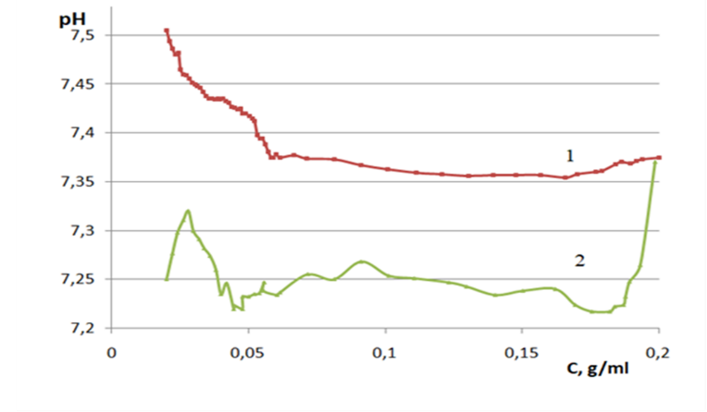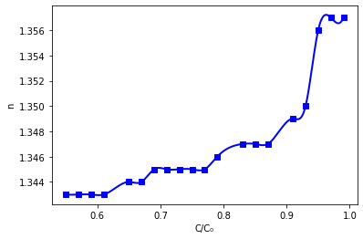

1. b)

Fig.1. Dependences of the ***pH*** index and refractive index of the aqueous solution of human albumin on the albumin concentration. The lower axis corresponds to the mass concentrations of albumin (g/cm3), and the upper axis to its volume concentrations. The protein concentration is reckoned in relative units: the lower axis corresponds to 𝐶/𝐶0, where 𝐶0 is the average concentration of proteins in human blood Curves 1 and 2 exhibit experimental data obtained at temperatures of 19 ∘C and 37 ∘C, respectively.

The permittivity was measured both for high - optical frequencies (by refractive index) and at low frequencies in a capacitor cell. These results should confirm the role of association of albumin molecules in homeostasis processes.

Fig.1b shows dependence of the refractive index of an aqueous solution of human albumin on the concentration of the protein component. As we can see, this dependence on optical frequencies has a characteristic behavior that is consistent with the dependences obtained earlier. Fig.2 shows dependence of the low frequency permeability of a water-albumin solution on the concentration of the protein component. This dependence is more complex, but we can see the same characteristic concentration as for the high-frequency one.

One of the most important problems of working with human blood products is ethical. Getting samples to work is very difficult and expensive. In short, doing so is very problematic. So, we suggested that albumin of a completely different nature - ovalbumin from a chicken egg - may have the same properties. If so, we could use it as a model to test experimental methods and identify basic patterns.

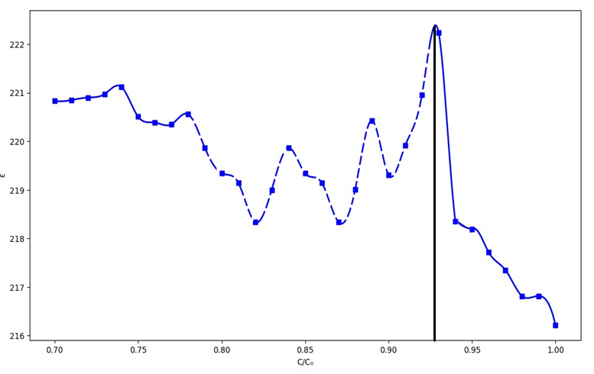

Fig.2. Dependence of the dielectric constant of an aqueous solution of human albumin on the concentration of the protein component. The protein concentration is reckoned in relative units: the lower axis corresponds to 𝐶/𝐶0, where 𝐶0 is the average concentration of proteins in human blood.

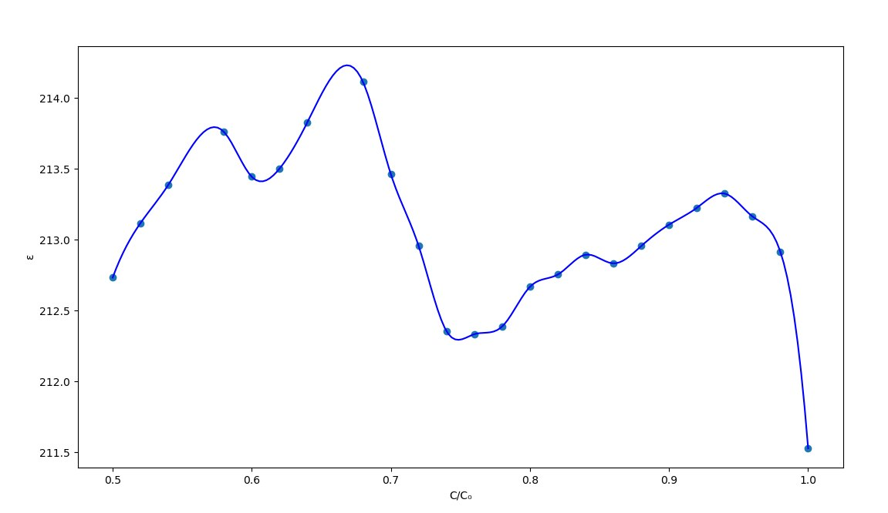



Fig.3 Dependence of the refractive index and permeability of aqueous solution of **ovalbumin** on the concentration of the protein component.

On the Fig. 3 you can see dependences of the concentration of the refractive index and permeability of aqueous solutions of ovalbumin. Therefore, these solutions show the same characteristic concentrations as human albumin solutions. That means that we may apply an ovalbumin as a model for more expensive and complex protein systems.

As a result, we obtain the diffusion coefficient and size of the particles. Actually, the scatter in the sizes of molecular associates in the range of characteristic protein concentrations is really large: from micrometers to tens of nanometers. This condition appears to be critical.

Thus, in this work we showed the peculiarities of the dielectric permittivity of water-protein systems. It was also shown that a complex aqueous solution of human albumin can be modeled using more available proteins. For example, with ovalbumin.

**Reference**

1.Malomuzh, N.P., Bulavin, L.A., Gotsulskyi, V.Y., Guslisty, A.A. Characteristic changes in the density and shear viscosity of human blood plasma with varying protein concentration/Ukrainian Journal of Physics, 2020, 65(2), стр. 149–154, 151. DOI: https://doi.org/10.15407/ujpe65.2.151

2. L. A. Bulavin, V. Ya. Gotsulskyi, N. P. Malomuzh, A. I. Fisenko I.I. Crucial Role of Water in the Formation of Basic Properties of Living Matter/ Ukrainian Journal of Physics, Vol. 65 No. 9 (2020) DOI: https://doi.org/10.15407/ujpe65.9.794

3. Solutions Malomuzh, N.P., Khorolskyi, A.V. Analyzing the Size of Albumin Macromolecules in Aqueous Rus. Journal of Physical Chemistry, 2021, 95(2), стр. 303–30.

**PHOTOLUMINESCENCE PROPERTIES OF ZnSe:Al, ZnSe:Cu NANOPARTICLES OBTAINED BY CHEMICAL SYNTHESIS**

Iryna Tepliakova

Research Supervisor: professor, Sc.D. Yu.Nitsuk

Experimental Physics Department,  
I. I. Mechnikov Odessa National University, Odessa, Ukraine

Semiconductor nanocrystals of A2B6 group are promising materials for semiconductor electronics, biomedical imaging and disinfection. Existing synthesis methods make it possible to obtain nanocrystals with a narrow size distribution, specified surface morphology and high stability. The ability to control the band gap and the luminescence wavelength makes these nanocrystals useful for optoelectronics. Luminescent semiconductor nanoparticles with wide absorption spectrum and pronounced luminescence peaks in the visible and near-IR regions are very promising for medical diagnostics

Among the semiconductor crystals of the A2B6 group, the most studied are CdS and CdSe. Cheap and simple method of obtaining, as well as high quantum yield of radiation in the visible region of the spectrum can be mentioned as the main advantages of these materials. A serious disadvantage of these materials is their cytotoxicity. Therefore, it is advisable to use nanocrystals of selenide and zinc sulfide for biomedical applications. In order to be used as markers for fluorescence tomography, nanocrystals must have effective radiation in red and near-IR regions. Aluminum and copper impurities are effective activators of radiation in these regions in bulk ZnSe crystals. Therefore, the optical and luminescent properties of ZnSe:Al and ZnSe:Cu nanocrystals were studied.

Zinc selenide nanocrystals were obtained by a chemical method. The source of zinc ions was zinc chloride, and the source of selenium ions was sodium selenosulfate. For doping with aluminum or copper, a 1% solution of aluminum chloride or copper chloride was added to a 10% solution of zinc chloride. The synthesis of nanoparticles was carried out in 1 ml of a 5% gelatin solution and had the following form:

ZnCl2+Na2SeSO3→ZnSe↓+Na2SO3+Cl2↑ (1)

ZnCl2+Al2Cl3+Na2SeSO3→ZnSe:Al↓+Na2SO3+Cl2↑ (2)

ZnCl2+CuCl2+Na2SeSO3→ZnSe:Cu↓+Na2SO3+Cl2↑ (3)

After removing residual reaction products, a colloidal solution of nanoparticles was deposited on a quartz substrate and placed in an oven until the polymer film dried. For X-ray diffraction and SEM studies, the solution was deposited on silicon substrates. On X-ray diffractograms, the dominant peaks were identified, which correspond to the (111), (220), (311) planes in ZnSe. Similar planes were found in ZnSe:Al and ZnSe:Cu nanocrystals.

For comparison, bulk ZnSe, ZnSe:Al and ZnSe:Cu crystals obtained by diffusion doping of Al and Cu impurities at various temperatures of growth were studied. The temperature varied from 750 to 900°C.

The optical density and photoluminescence spectra were investigated to establish the nature of optical and luminescent transitions in studied nanocrystals as well as to determine the average size of nanoparticles and the concentration of an optically active impurity. For this purpose, the sets of samples with different ratio of initial and impurity components were selected.

The optical density spectra of undoped ZnSe nanocrystals showed that a decrease in the concentration of the initial zinc chloride and sodium selenosulfate from 0.1 g/ml to 0.01 g/ml leads to a shift of the band gap towards high energies from 3.3 to 3.78 eV, which is confirmed by the colloidal solution color change from pale yellow to colorless.

The average radius of the nanoparticles was estimated by SEM and in the effective mass approximation by the change in the band gap.

Doping with aluminum or copper shifts the optical absorption edge to lower energies. In this case, the magnitude of the shift increases with growth of dopant concentration. A similar low-energy shift is observed in bulk ZnSe:Al and ZnSe:Сu crystals. This shift cannot be explained only by the particle size increase. In bulk crystals, such a shift is explained by inter-impurity Coulomb interaction, which is a characteristic of group III elements and transition element impurities. The concentration of aluminum and copper in the studied ZnSe:Al nanocrystals was calculated from the value of the shift of the band gap between undoped ZnSe nanoparticles

Investigation of ZnSe nanocrystals photoluminescence spectra has shown the presence of broad photoluminescence bands localized in the 550-850 nm region. The change in the temperature of nanocrystals from 300 to 430 K did not cause a shift in the studied spectra. The position of the spectra remained unchanged even with a change in the band gap width of nanocrystals. The presence of a number of bends and a large (~ 150 nm) half-width of the bands indicate their non-elementary nature. The spectra modeling by elementary Gaussian components program revealed a series of elementary emission lines localized at 580, 600, 630, 680, 700, 750 and 800 nm. The identical elementary emission lines were observed earlier in bulk ZnSe single crystals.

Emission at a wavelength of 580 nm appears due to associative native defects (VZnVSe)-. The emission line at a wavelength of 600 nm appears due to associative defects (VZnDSe)- where the donor is either VSe or an uncontrolled donor impurity, an VII group element, for example, Cl, Br, I. The other emission lines were associated with defects (VZnDZn)- with different distances between donors and acceptors. Here the donor is the uncontrolled Al, In, Ga impurities.

Doping with aluminium during the growth of nanocrystals leads to an increase of the emission intensity in the 500-1000 nm region. Further increase of the emission intensity with increasing Al2Cl3 concentration is explained by an increase of the donor impurity concentration in investigated nanocrystals.

In the emission spectra of ZnSe:Al nanocrystals, elementary emission lines are emitted at 580, 600, 630, 680, and 700 nm. It was found that a change of Al2Cl3 concentration and the choice of the stabilizing matrix type do not lead to a shift of the elementary and integral emission lines to the short-wave or long-wave region. The change in technological conditions leads to a change in the intensity of the elementary emission lines, which is explained by the redistribution of the concentration of native and impurity defects that create the associative centers. The shift of the emission integrated maximum to the smaller wavelengths region with increasing Al2Cl3 concentration from 0.001 to 0.002% can be explained by increasing in the intensity of the elementary emission line at 600 nm due to associative defects (VZnClSe) -.

Doping of ZnSe nanocrystals with copper during the growth process leads to a shift of the emission spectra to the shortwave region. The photoluminescence spectra of ZnSe:Cu nanocrystals with a CuCl2 concentration of 0.001–0.003% are broad non-elementary emission bands localized in the region of 500–750 nm. The decomposition of the spectrum into elementary Gaussian components allowed us to identify a series of lines with maxima at 520, 540, 590, 660 nm. Elementary radiation lines with such maxima are not observed in undoped ZnSe nanocrystals. In bulk ZnSe: Cu crystals at T = 300 K, the emission bands at 590 and 660 nm are also detected. In bulk crystals he emission band at 550 nm at T = 77 K is observed. The emission lines in bulk crystals and polycrystalline ZnSe films are not connected with isolated CuZn, but are caused by the complexes. The emission line at 520 nm is due to transitions (CuZn-, VSe+)-. The radiation line at 540–550 nm is associated with transitions within the associative center (CuZn–, ClSe+)-. The emission line at 660 nm is due to radiative transitions involving doubly charged copper ions within the donor-acceptor pair (CuZn2-, ClSe+)-. The emission line at 590 nm is most likely due to transitions involving a doubly charged copper ion and a single-charged selenium vacancy within the center (CuZn2-, VSe+)-. A further increase in the concentration of copper chloride to 0.005% and more leads to strong absorption in the near-IR region and concentration quenching of the observed radiation lines, and the colloidal solutions of the nanoparticles become dark gray in color.

ZnSe, ZnSe:Al, ZnSe:Cu nanoparticles with a diameter of up to 10 nm were successfully synthesized using "green" synthesis method and organic stabilizing agents. The nature of radiation transitions in ZnSe and ZnSe:Al, ZnSe:Cu nanocrystals have been established. It was experimentally confirmed that the emission lines caused by the luminescence on donor – acceptor pairs in nanocrystals are identical to the emission lines in bulk crystals. This proves that ZnSe:Al and ZnSe:Cu nanocrystals can be effectively used as a material for biomedical visualization, optoelectronics, etc. due to both optical and luminescent properties, and simplicity and low cost of fabrication technology.